**IOT Application Document**

SMART HOME USING IOT

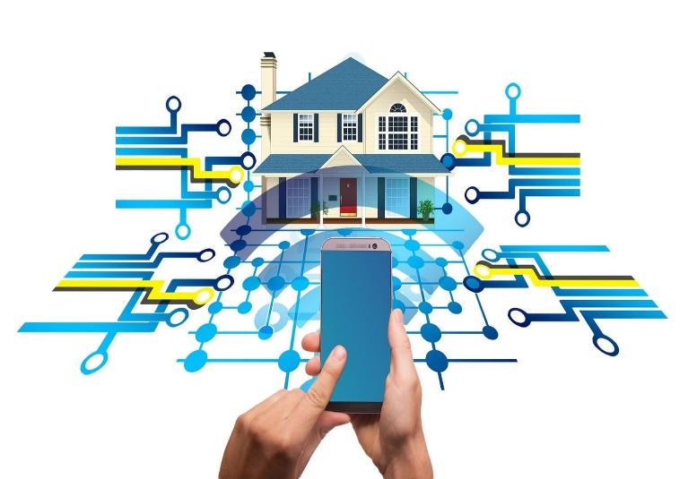

Dated: 08/02/2022

**Submitted by:**

Karkar Kaushal (190040107021)

Bamroliya Jay (190040107001)

**Guided by:**

Pro. Nisha Vadodariya.

**INDEX**

1. Introduction
2. Study of existing system & identifying probable improvements in existing system
3. Importance
4. Requirement for IOT setup
5. Framework
6. Architecture
7. How does it work?
8. Conclusion
9. Reference

**Introduction**

* Today, technology has become an integrated part of people's lives. It has, and continues to influence many aspects of daily life and has allowed better social interaction, ease of transportation etc.
* Home automation or sensible home may be delineated as introduction of technology within the home atmosphere to provide ease and protection to its occupants. Home automation or sensible home may be delineated as introduction of technology within the home atmosphere to provide ease and protection to its occupants.
* By using the technology of the Internet of Things, the examination and execution of home automation have got additional average.

**Why smart home?**

Smart Home is Applicable in various aspect of our home and environment to suite our different preferences

* Comfort or Ease of Control
* Entertainment Security
* Convenience all time
* Life time personalization
* User friendly

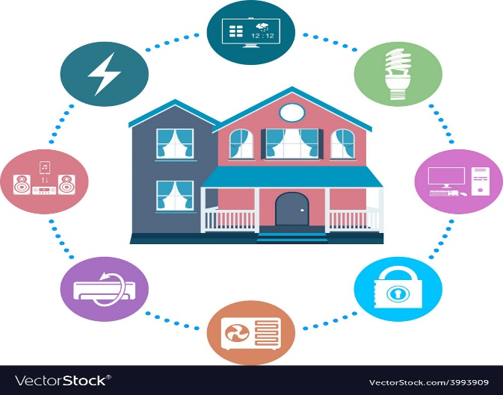

**Study of existing system & identifying probable improvements in existing system**

* Due to growing popularity of smart home systems, smart home security is a topic which is becoming increasingly important. Internet of Things (IoT) devices are obtaining increasing access to private data, but very often it does not mean that improved security mechanisms and mechanisms guaranteeing availability are implemented.
* The main problem is limited computing power and the limited memory of the nodes used in the network.
* Moreover, IoT systems are increasingly often managed through the cloud, which causes that their interfaces are available over the Internet.
* Another problem is the lack of expertise of users which can lead to configuration errors potentially causing data loss and hacker attacks. In this paper, we face up security and

availability issues in smart homes and propose an edge-of-things solution that focuses on putting the management of the home at the edge.

* Another problem is the lack of expertise of users which can lead to configuration errors potentially causing data loss and hacker attacks. In this paper, we face up security and availability issues in smart homes and propose an edge-of-things solution that focuses on putting the management of the home at the edge.
* The results show that the proposed edge-of-things solution is able to solve many of the challenges that current smart home applications present

**Importance of IOT**

* The internet of things helps people live and work smarter, as well as gain complete control over their lives. In addition to offering smart devices to automate homes, IoT is essential to business.
* IoT provides businesses with a real-time look into how their systems really work, delivering insights into everything from the performance of machines to supply chain and logistics operations.
* IoT enables companies to automate processes and reduce labor costs. It also cuts down on waste and improves service delivery, making it less expensive to manufacture and deliver goods, as well as offering transparency into customer transactions.
* As such, IoT is one of the most important technologies of everyday life, and it will continue to pick up steam as more businesses realize the potential of connected devices to keep them competitive.
* The importance of IoT is its influence. The Industrial IoT goes beyond the simple exchange of data by connecting devices, systems and people in intelligent, real-world applications to enable environments such as automated factories, smart cities and connected healthcare
* The Industrial IoT is defined as the automated interaction between smart devices and systems, exchanging data to an offsite or cloud-based solution for meaningful, time-sensitive analytics using components with very low energy consumption, that are simple to install and based on industry standards.
* Traditional embedded systems are at the heart of this phenomenon, having evolved from standalone systems to become a network of connected devices and systems.

**Requirement for IOT setup**

* Internet connection
* Sensors & Devices
* Conclusion
* Cloud
* Master Hub
* Processors
* Controller
* Security and Privacy Protection
* Communications
* Applications
* Power Hub
* wi-fi & Bluetooth
* Relays
* User interface

**Framework**

**Architecture of smart home**

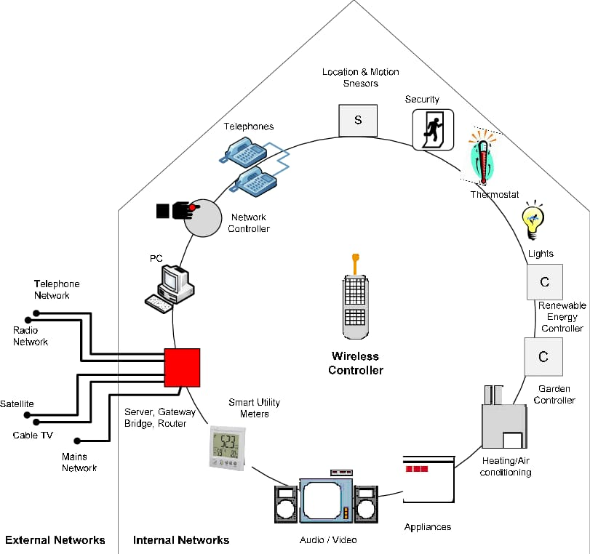

**How does it work?**

* A smart home’s devices are connected with each other and can be accessed through one central point—a smartphone, tablet, laptop, or game console. Door locks, televisions, thermostats, home monitors, cameras, lights, and even appliances such as the refrigerator can be controlled through one home automation system.
* The system is installed on a mobile or other networked device, and the user can create time schedules for certain changes to take effect.
* Smart home appliances come with self-learning skills so they can learn the homeowner’s schedules and make adjustments as needed. Smart homes enabled with lighting control allow homeowners to reduce electricity use and benefit from energy-related cost savings.
* Some home automation systems alert the homeowner if any motion is detected in the home when they're away, while others can call the authorities—police or the fire department—in case of imminent situations.
* Once connected, services such as a smart doorbell, smart security system, and smart appliances are all part of the internet of things (IoT) technology, a network of physical objects that can gather and share electronic information

**Advantages**

* Flexibility
* Programmatically control devices
* Better scalability and security
* Energy saving
* Improved comfort and safe

**Disadvantages**

* High cost
* Damage of cable affect entire system
* Signal receiving problem
* Human error occur
* Huge system crash

**Conclusion**

* we have introduced the event of a home management .
* security system exploitation using Raspberry pi and loT.
* The system is suitable for remotely controlling the home appliances.
* The system may be employed in many places like banks, hospitals etc.

**References**

[**www.slideshare.net**](http://www.slideshare.net)

[**www.toptal.com**](http://www.toptal.com)

[**www.investopedia.com**](http://www.investopedia.com)

[**www.wikipidia.org**](http://www.wikipidia.org)

***THANK YOU***